Project Design Phase-II
Technology Stack (Architecture & Stack)

Date | 25 June 2026
Team ID
Project Name | An employee requests installation of licensed software through the Service Catalog
Maximum Marks | 4 Marks

Technical Architecture:
The Deliverable shall include the architectural diagram as below and the information as per the table1 & table 2
Example: Software Installation Request System
Reference: https://developer.ibm.com/patterns/ai-powered-backend-system-for-order-processing-during-pandemics/

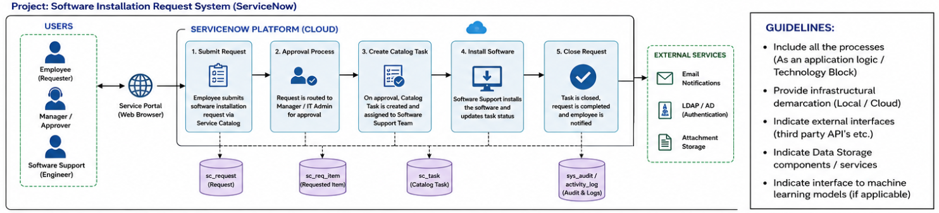

Table-1 : Components & Technologies:
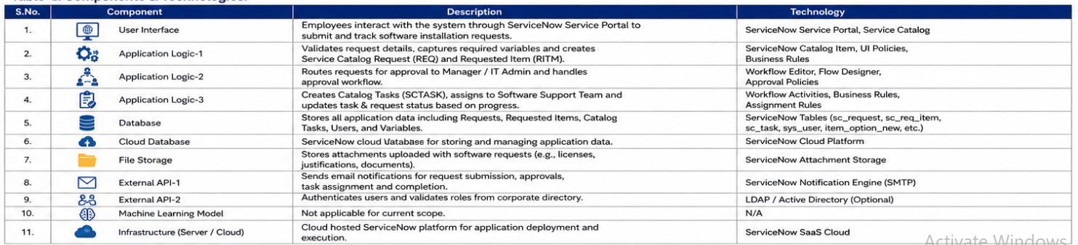
Table-2: Application Characteristics:
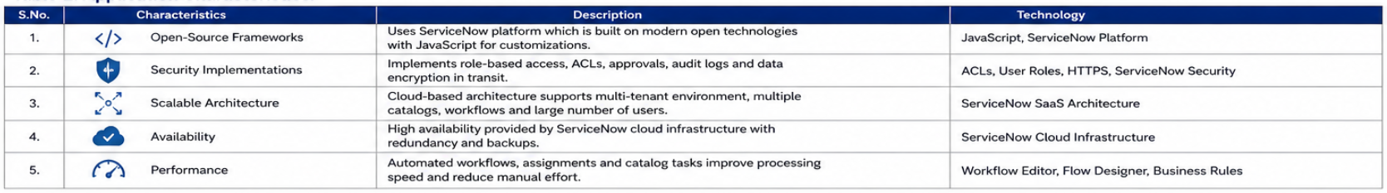
References:
https://c4model.com/
https://developer.ibm.com/patterns/online-order-processing-system-during-pandemic/
https://www.ibm.com/cloud/architecture
https://aws.amazon.com/architecture
https://medium.com/the-internal-startup/how-to-draw-useful-technical-architecture-diagrams-2d20c9fda90d

